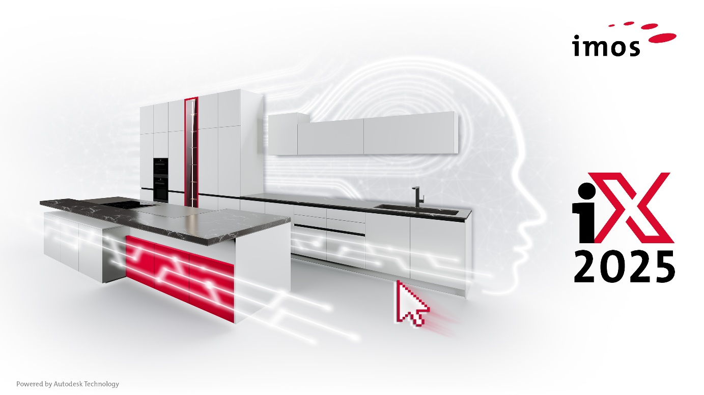
Making the Transition to Digital Furniture Manufacturing Easy

imos AG Presents an Innovative Software Solution for Small Businesses and Startups
imos AG, one of the leading providers of software solutions for furniture and interior design, is targeting startups and small businesses in the craft sector with its new entry-level solution, imos iX CAD/CAM CS. This innovative software package combines the full power and flexibility of the iX CAD 2025 design tool with an online CAM service into an integrated platform, offering businesses an efficient and user-friendly solution to optimize their design and manufacturing processes. The pricing and licensing model are attractively designed to meet the needs of smaller enterprises.
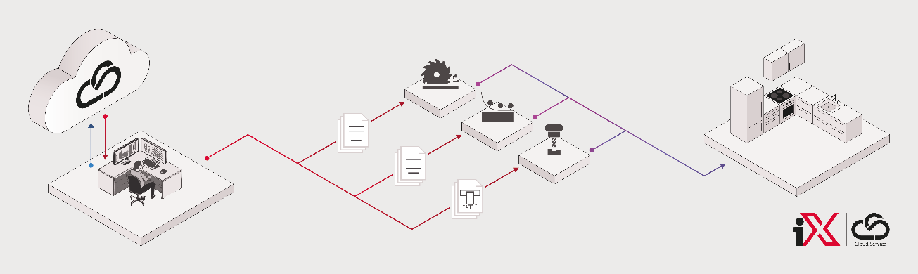
Flexibility for Growing Businesses
As a business grows, so do its tasks and the demands on its software solution. Additional workstations may need to be integrated, more machines connected, or even online sales solutions developed. All of this and more can be addressed with the standard products and services offered by imos AG. This ensures that a company’s growth strategy is not restricted or hindered by its software solution but is instead supported and facilitated.
Investment Security and Continuous Development
Another advantage is that the master and motion data generated during the work process with the entry-level solution remain consistent as the company evolves. This protects the investment made in creating and maintaining the data. The same applies to employee training, as the knowledge gained can be gradually expanded. However, the solution is not just for beginners. "For companies already using CAD/CAM software, iX CAD/CAM CS is the ideal solution for transitioning to our technology," says Winfried Dell, Head of Sales at imos AG. "The subscription-based licensing model means that only monthly fees are incurred, eliminating the need for an initial investment." iX CAD/CAM CS is based on the new iX 2025 version and will be available starting November 2025.
______________________
About imos AG:
imos AG develops and distributes software for furniture and interior design worldwide. The CAD/CAM software integrates the design of furniture and interiors, including fittings from furniture suppliers, into a seamless process – from internet-based room planning and order entry to costing and the control of modern CNC machines. imos AG is internationally recognized as a key innovator in the digital evolution of the furniture industry. The company focuses on developing and distributing innovative system components for the furniture and woodworking sectors.
The product range connects sales, design, and construction with production planning and manufacturing into a fully digital process. Configurable to meet specific needs, imos solutions are used by internationally leading industrial companies as well as highly specialized craft businesses producing custom designs.
In addition to its headquarters in Herford, East Westphalia – the center of its development activities – imos AG supports over 5,000 users in 91 countries through a global network of 45 sales and service partners. The software is available in 27 languages.
Press Contact: imos AG
Albina Isma
Planckstr. 24
D-32052 Herford
Tel.: +49. 5221.976-145
aisma@imos3d.com
www.imos3d.com/en

